Michael Redford
IS315

Data Analysis

Data Flow
The system uses data from multiple sources to work. Input is taken in from different departments. Staff will be able to input necessary components to make allow the system to work. Staff & management will be able to track multiple processes at once to get an idea of how this will be running. Reviews can be input into the system along with genre data. This will be handled with reports and invoices.
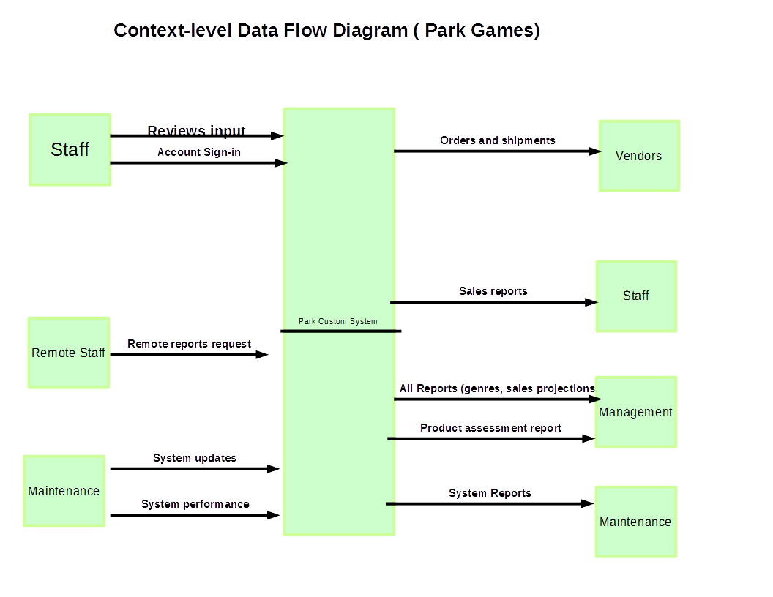
Context Level Data Flow Diagram

Elements
The staff with have an account created for them by IT. This will allow them to perform functions depending on there role. Sales can input preorder data. Advertising may only be allowed to input reviewed. All staff can view all reports but may not make changes remotely.

Data Structure
The framework for this system is being developed by scratch. There must be a vast & inclusive database that can handle multiple data types. Data structures must correctly typed and programmed efficiently to be easily expanded on for new features. A database structure seems appropriate for organizing & expanding this.
Data Storage
Parks games custom system will utilize an open source database technology such as MongoDB. The choice is simple as MongoDB allows park to easily use a CMS to visualize information and generate reports and analytic. Sections to plan for are the following:
- Accounts
- Roles
- Preorders
- Games
- Genres
- Sales
- Inventory
- Stats
- Generated case scenarios
- Generated projections for comparison
Databases will be held for all sections to effectively achieve Park Games goal.

